Early Help is support you can get for you and your child from wither school or in the community

What is Early Help


Early Help is support you can get for you and your child from wither school or in the community


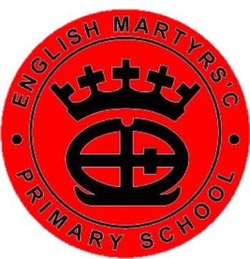


At English Martyrs’…

Health Visitor
Health Visitor

Open Door for all
SENDCo
Rainbows
CFW


Health Visitor
CAMHS
ELSA
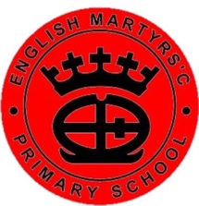
Triple P
Social Skills
Citizens’ Advice
In our Community

GP & Practice Nurse
Young Minds
Safeguarding Team
Pantry@EM

